BARBERTON SPORTS HALL OF FAME
P.O. Box 214 Barberton Ohio 44203
Rob Culbertson - President

June 2023:
Wow how time flies! It doesn’t seem possible, but the Barberton Sports Hall of Fame will be celebrating its 45th anniversary this year. Thank you to everyone who have blessed us with their time and efforts in order to build such an outstanding organization.
Greetings to the current members, prospective new members, previous advertisers and prospective new advertisers.
Thank you for your continued support of the BSHOF. We are looking forward to this year’s BSHOF induction banquet. We would like to thank you for your continued support of the BSHOF. Your efforts on are behalf are greatly appreciated.
We will be celebrating the class of 2023!

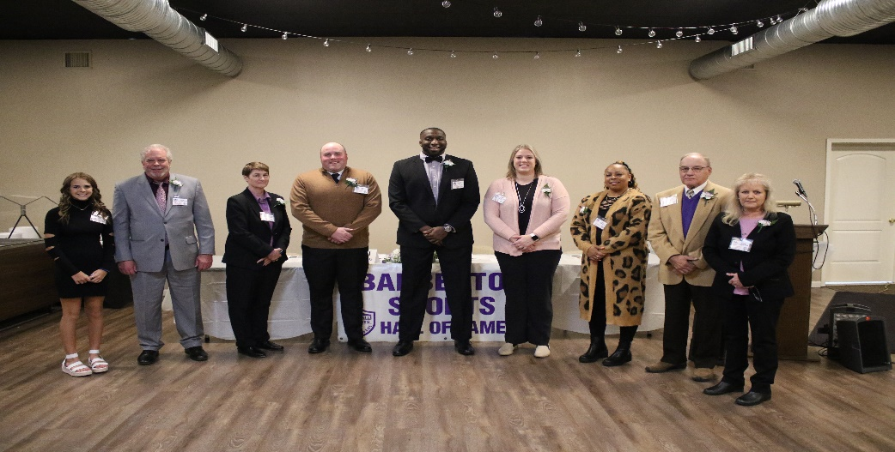
The BSHOF Class of 2022: Charlee Winebrenner & Rob Winebrenner (representing Justin Winebrenner), Anne- Marie Anderson, Ryan Breon, Garrett Sims, Mary Stockdale Miller, Asia Triplett, David Kapes, Kim Okolish
We would like to congratulate and are excited to announce the Barberton Sports Hall of Fame inductees for the class of 2023. The members of the 2023 class include the following:

- Herman Dunwald- Football
- Jason Morr- Wrestling
- Jacob North- Basketball
- Mike Pokopac- Baseball
- Todd Sabol- Soccer
- Jim Smart- Basketball
- Pat Herold- O.C. Barber Award
- I. A. Building- President’s Award

IN MEMORIUM: We would like to remember two of BSHOF members who passed away the past year. Please remember Elwood Palmer and Rudy Sharkey.

BSHOF INDUCTION BANQUET INFORMATION

The 2023 BSHOF Induction ceremony will be held at the Al’s Meats Banquet Facility on Wednesday November 22, 2023, with cocktails at 5:30 PM, followed by dinner at 6:30. Tickets are available for this event. Ticket prices are $50.00 for adults and $20.00 for children. Banquet and ticket information can be found in the newsletter.

BSHOF MEMBERSHIP & INDUCTION BANQUET INFORMATION

2023-2024 DUES (July 1 through June 30 each year)
______ Single Membership $10.00
______ Single Patron Membership $15.00
______ Couple Membership $20.00
______ Couple Patron Membership $25.00
______ Donation $_____
TOTAL ___________________
Banquet Tickets 2023 (On the back of this page, please include each person attending, DEADLINE is November 15, 2023)
______ Single Ticket @ $50.00 per ticket $_____
______ 8 Place Table @ $350.00 per table $_____
Here to Honor: _________________, all or: ____________________
______ Herman Dunwald ______ Jim Smart
______ Jason Morr ______ Pat Herold
______ Jacob North ______ I. A. Building
______ Mike Pokopac
______ Todd Sabol
Place me at a table with ______________________ if possible.
2023 PROGRAM ADVERTISING: Must be in by October 1, 2023 to be included in the program.

_______ 1/8 Page $50.00
_______ ½ Page $100.00
_______ 1 Page $150.00
_______ Continue ad in present form
_______ Make the changes herein provided
_______ New ad- setup enclosed TOTAL: $________
Make checks payable to: Barberton Sports Hall of Fame, P.O. Box #214, Barberton, Ohio 44203

Company ____________________ Person __________________
Address _________________________________________________
_________________________________________________
Signed ______________________ Date ____________________
BSHOF USE: Check # ___________ Deposit date _____________

